every tear of paper files and other things, as well as there is a big ability for losing or damaging the documents. They choose this type of grading system because it much easier and faster to all students in this university.

The developers of the study examine the task of learning to develop a System/website that could lessen the process of encoding and decoding of student’s data and information that technology is the commonly used in any transactions. This system will be a big help for the juniors and senior’s students of Stella Maris academy by keeping tracks of their current grades per grading terms and also on viewing their grades every end of the semester.

**Purpose and Description**

The purpose of the system is to allow the students to view their grades anytime and anywhere by using their students profile account then the teachers/faculty could also submit the grades of every student directly to the system which can help and make flow easy.

Online submission and viewing of grades that very applicable to all junior and senior high school students of Stella Maris Academy because as we all know some of the students complaining because of the slow and crowded queuing process in the registrar’s office.

**Objectives of the Study:**

**General Objective:**

Grading System aims to develop easy way of submitting and viewing of grades of each student which can help to implement good and accurate system to the institutions. The proponents gave their best to satisfy the current needs of the users by making an online submission and viewing of grades, that will keep all the records of the students during releasing the grades per-grading system.

**Specific Objectives:**

1.To design and develop an online grading system in juniors and senior students of Stella Maris Academy with the following features:

a. To provide a convenient and reliable system to Stella Maris Academy.

b. To secure all the student’s data or grades for the whole academic year.

c. To give parents/guardian an easier way to monitor the grades of their children.

2. To evaluate the system using the following criteria:

a. Reliability

b. Functionality

c. Accuracy

d. Maintainability

e. Usability

f. Durability

g. Security

h. Portability

**Scope and Limitations**

The proposed system provides an accurate submission of grades by the teachers and online viewing of grades for the students using an android application. The students could view their grades anytime and anywhere through online using their android phones or smartphones by login their unique ID number and password which the student can view their grades without editing and any changes the data.

The proposed system is limited because it doesn’t support some of the following features like using of barcode for tracking of products, and biometric scanner for the security of the system.

The proposed system provides an accurate submission of grades by the teachers and online viewing of grades for the students using an android application. The students could view their grades anytime and anywhere through online using their android phones or smartphones by login their unique ID number and password which the student can view their grades without editing and any changes the data.

**Significance of Study**

This study is significant and essential for the following:

* **Administration** –the result of this study will store and record all the data or information of all the students in the institution, comfortability in term of submitting and viewing of grades and to lessen the burden of each registrar staff and by keeping the grades of every junior and senior’s students of Stella Maris Academy.
* **Future Researchers –** the result of this study will offer significant information to future researchers in conducting similar studies covering other variables that are not contained within. This study could serve as reference for future undertaking. Will benefit the next generation and helps them to develop their works specially in getting some related studies.
* **Researchers –** this study is an additional exposure on the part of the researchers to advance their skills in creating research paper, programming languages, etc., and making this as one of their credential for future purposes. And used the cited references and relate to the proposed system and improve the current system.
* **Students** – the result of this study will provide them an easier and accurate way by viewing their grades per grading system which they can view their information anytime and anywhere using their profile account.
* **Teachers/Faculty** – the result of this study this will undergo an easier process by submitting the grades of every student in this institution.
* **Parents/Guardian**– the result of this study will have an easier way to show the grades of the students, the one that should check the student grades per grading period which they can identify if their children get a high grades or not, and they are the end users.

**Definition of terms**

For the clarification of the particular words used in the system, the key word that has been used in this study will be defined as follow:

* **Administration *–*** a group of people who manage the way a company, school, or other organization functions.

In this study, term was used as the one that is capable in storing and keeping all records, data, and information of the students. The persons who has a biggest role to operate and manipulate the system.

* **Faculty/Teachers** – the faculty members or the group of teachers in school or college. One of the powers of the mind or body.

In this study, term was used as the one who are responsible in computing the grades of all the students correctly by the process of gradingsystem. And the one who responsible of uploading the grades of the students to the system.

* **Flow**– to move in a continuous in smooth way.

In this study, term was used as the one that synchronize process of a system to move in a continuous.

* **School**– an organization that provides instruction.

In this study, term was used that the Stella Maris Academy who will be able to use the system of the proponents proposed.

* **Students**– the people who attends the school, college or university.

In this study, term was used that the students will be able to use the application to view their grades using their mobile phones.

* **Submission**– an act of giving a document, proposal, piece of writing etc., to someone so that it can be considered or approved: an act of submitting something.

In this study, term was used that act of uploading the grades from the teachers to the system.

* **Viewing** – an act of seeing, watching, or taking a look.

In this study, term was used that act by the students to view their grades using the application from their mobile phones.

* **Online**– connected to a computer, a computer network, or the internet.

In this study, term was used which an act on the students who connected to the internet so that they can view their grades through online.

**CHAPTER II**

**REVIEW OF RELATED LITERATURE AND PRIOR ARTS**

This chapter present the reviews of related works and studies that deals in creating an online submission and viewing of grades of juniors and seniors’ students of SMA. The scope of these concepts provides multiple articles from different sources were used to familiarizes and to authenticate the needed data for the study.

**Related Concepts**

The proponents conducted a research with the use of books and internet to provide related literature and prior arts system that are applicable in the development of the system.

**Local Prior Arts**

The proponents searched for a detailed analysis conducted by the experts locally in this field which could help them in developing their proposed system.

**Cashier’s Assessment System of Jose Rizal Memorial State University**

It is an advantage for a school to have an online cashier’s assessment system against its competitors. Aside from being an advantage, it is also a marketing strategy for the school. It is one of the reasons why schools tend to do online cashier’s assessment system rather than the tradition one. One key tool in this period is to use a web based application that will assure secured system of assessment and accounting for a certain school. An online enrollment system is a quick and efficient way for students. Through online cashier’s assessment system, student can enroll via online anywhere or without going out to school thru the website of the school in internet. This study aims to come up with an online cashier’s assessment system for Jose Rizal Memorial State University which contains information relevant data such as name, year, section, miscellaneous fees and other fees paid. This system is designed for the use of the registrars and administrators in enabling them to make their work easier and more comprehensive. Not only will the system be effective in making the online cashier’s assessment system fast but also make the records safe and more reproducible. The system will reduce the cost of operation through less use of resources such as paper, ink, and other office supplies. It also allows less room for errors in recording and computations due to the automated nature of the proposed system. It increases file security with less risk from unauthorized access. Overall, the proposed system increases the efficiency of the school’s enrolment system by automating the tasks. (Kevin,2013).

The proponents can relate this system to the proponent’s study by providing the students and teachers an online service in submission and viewing of grades. because the proponents use server based system that can be accessed by the students online and the teachers could submit the grades of the students by the use of the proponent’s system.

**Automated Grading System, Eduardo barrette SR. National High School**

The grade of a student is a scale which determines students who need more improvement and require more assistance which will help teachers in guiding them towards their development.   It also shows where students excel most so they can be honed and encouraged to continue their good work, improve more, and aim higher.   At the end, it will be the reference for the judgment of whether a student can step up to a higher level of learning or remain to be polished.   From these reasons, it is clearly concluded how important it is to make sure that the grades of the students are accurately calculated and safely stored in a well-founded database. It is understood that in the traditional grading system, where only calculators and papers are present, it is very difficult and time-consuming to compute grades. (James, 2013).

The proponents can relate this system to the proponent’s study because it is important to make sure that the grades of the students are calculated automatically and has a security when the data are stored in the database. It can also accelerate its progress by the cooperation of the school officials. And the registrars don’t need to use a manual way of computing the grades of all students.

**Foreign Prior Arts**

Foreign references helped the proponents to expand their ideas in developing their proposed system.

**Validation of the Learning Transfer System Inventory: A study of supervisors in the public sector in Jordan**

Jordanian policymakers rely on trained supervisors to lead organizational change in public administration. The impact of training, however, remains weak unless trainees apply what they have learned (training transfer). In order to assess training transfer, the present study validates a Classic Arabic version of the Learning Transfer System Inventory (CALTSI). The instrument was administered to a random sample of 500 supervisors. Exploratory factor analysis with oblique factor rotation validates 15 of the original 16 factors of the LTSI and explains about 65% of the common variance. These findings and their implications are discussed. ([Abdulfattah Yaghi](https://onlinelibrary.wiley.com/action/doSearch?ContribAuthorStored=Yaghi%2C+Abdulfattah) and [Doug Goodman](https://onlinelibrary.wiley.com/action/doSearch?ContribAuthorStored=Goodman%2C+Doug), 2008).

This study is related to proponent’s system because of the same functionality which very workable system the way the systems record the student’s grades. And to provide the best way, in order to calculate grades of each students and keep the records safety until the next generations comes.

**Grading System Rationale**

Few issues have created more controversy among educators than those associated with grading and reporting student learning. Despite the many debates and multitudes of studies, however, prescriptions for best practice remain elusive. Although teachers generally try to develop grading policies that are honest and fair, strong evidence shows that their practices vary widely, even among those who teach at the same. For the first paper the scores ranged from 64 to 98, and the second from 50 to 97. Some teachers focused on elements of grammar and style, neatness, spelling, and punctuation, while others considered only how well the message of the paper was communicated. The following year Starch and Elliot repeated their study using geometry papers submitted to math teachers and found even greater variation in math grades. Scores on one of the math papers ranged from 28 to 95–67-point difference. These demonstrations of wide variation in grading practices led to a gradual move away from percentage scores to scales that had fewer and larger categories. One was a three-point scale that employed the categories of Excellent, Average, and Poor. Another was the familiar five-point scale of Excellent,

Good, Average, Poor, and Failing, (or A, B, C, D, and F). This reduction in the number of score categories served to reduce the variation in grades, but it did not solve the problem of teacher subjectivity. To ensure a fairer distribution of grades among teachers and to bring into check the subjective nature of scoring the idea. (Howard R. Pollio, 2013).

This study is related to proponent’s system by allowing the teachers submit the subjective grades of the students easier and faster. It also shows where students excel most, so that they can be encouraged to continue their good work, improve more, and aim higher. The teachers can automatically calculate the information of each student with grading policies that are honest and fair, then the teachers must have a strong evidence to be showed to each students.

**Synthesis of Related Literature**

The comparison below shows the different features of the proposed system that was compared to the Online Submission and Viewing of Grades with Android Application for Junior and Senior Students of Stella Maris Academy. This table of comparison is composed of features possessed by every system on the internet.

Table 1. Features and comparison of foreign and local system

|  |  |  |  |  |  |  |
| --- | --- | --- | --- | --- | --- | --- |
| Related Studies | Features | | | | | |
|  | Portability | Connectivity | Online  Submission | Android  Viewing | Security | Main-  tenance |
| Cashier’s Assessment System of Jose Rizal Memorial State Univer  Sity | NO | OFFLINE | NO | NO | NO | YES |
| Automated Grading System, Eduardo barrette SR. National High School with Android Applica  tion | NO | OFFLINE | NO | NO | YES | YES |
| Validation of the Learning Transfer System Inventory: A study of supervisors in the public sector in Jordan | NO | OFFLINE | NO | NO | YES | YES |
| Grading System Rationale | NO | OFFLINE | NO | NO | YES | YES |
| Online Submission and viewing of grades of Stella Maris Academy | YES | ONLINE | YES | YES | YES | YES |

Table 1. Online Submission and Viewing of Grades with Android Application for Jr. and Sr. Students of SMA features Comparison Table of Related Application and System.

**Local Related Literature**

The local related studies are the studies conducted here locally or within the Philippines.

**Computerized Grading System**

This study attempts to develop a Grading System that may eliminate the word “manual”. To that, it will lessen their time and effort for computing of grades.   And eventually they may avoid rushing submission of grades. Another capability of the proposed system is storing and accessing old data. Grading System for Data Accuracy will help a lot in the part of teachers, school, administration and as well as the security of data of students. Today, many colleges and universities still use automated system in daily life. But there are so many schools are still using manual system. Grading System is the most commonly used in computing and analyzing the performance, talents and skills of the students. It is the important record to keep. (Elli john Buenviaje,2015)

The proponents can relate this system because the study of Online Submission and Viewing of Grades is the only way to eliminate the word manual grading system which the students and teachers/faculty can lessen the burden when it ends of term or semester.

**Grading System of San Francisco St. Manuyo, in Las Piňas City**

**(Nuemann Academy)**

As pre-school with an initial enrolment of 70 students and only 4 faculty members. From then on, the academy increases in its population statistics year after year, to date it opens its High School Department with an initial number of 9 enrollees in the first year level. Nuemann Academy Incorporation is housing its students in a three story building occupying a more or less one-hectare lot with adequate number of learning classrooms for students. Amenities are complete from library to computer laboratory. Neumann Academy Incorporation used a manual grading system on their past years of operating the school. They usually use to right the scores and grading of their students on class records manually. Then after every grading period the teacher/faculty computes all recorded grades of all the students they handle one by one also in a manual way. After computing the grades manually, the teachers will send the computed grades to the principle for approval so that the grades with permission may now distribute by the teachers. Grading System able the teachers a quick and easy to track the student’s grades. (Mr. George Neumann and wife Dr. Hedilisa A. Neumann,2013)

The proponents can relate this system to the proponent’s study because Online Grading System of San Francisco St. Manuyo also aim to provide on how to solved their problems and will provide convenient and reliable system which the students and teachers/faculty can lessen the burden when it ends of semester.

**Foreign Related Literature**

The foreign related studies are the studies conducted internationally or outside the Philippines.

**Alignment of Two Grading Systems: Margent Hohner, Thompson Rivers University, Canada**

One of the many challenges in coordinating the program across the different locations has to do with the different grading system here in abroad. Grading system with in nation and around the world vary widely, and in Canada, grading system vary by provinces, level of education, institutions, and even by different divisions within the same institution. The grading system in place at the small Canadian university differs from the Chinese grading system and hence, there is a need to re-align the grading systems in order to create uniformity and standardization so that comparability and comfortability can be conducted (Feagles,1999) and program requirements met. (Panagiotis Tsigaris,2013)

The proponents can relate this system to the proponent’s study because it can give comfortability and conducted an easier and faster system/website to all clients and they can lessen the works of each students because they don’t need to go back to school to re-align in the registrar’s office.

**Online Grading System with Online and SMS Grade Inquiry**

Grading System with Online and SMS Grade Inquiry is an exercise in the professional judgment on the part of the teachers. The system is very liable and faster and more usable if it is made online. Using this system gives advantages to the parents or a guardian for it allows them to view the performance of his/her child through online, anytime, anywhere provided there is an internet connection. To develop a system that the parents can easily access their child’s and a system that will monitor the attendance of students. (Desousa ,2008)

The proponents can relate this system to the proponent’s study because the parents of the students can access the grades of their children and they can also accelerate its progress by the cooperation of the school officials. And the teachers don’t need to use a manual way of computing of grades and adding information of all students and develop a system that compute grades correctly.

**Table of Comparison**

The table shows the list of the prior system both local and foreign system and different features that compare on the features of Online Submission and Viewing of Grades with Android Application for Jr. and Sr. Students of SMA.

|  |  |  |  |  |  |  |  |
| --- | --- | --- | --- | --- | --- | --- | --- |
| Related Prior Arts | Features | | | | | | |
| Computerized Grading System | Portability | Connectivity | Online  Submi-  ssion | Android  Viewing | Secu-  rity | Main-  tenance |
| Grading System of San Francisco St. Manuyo, in Las Piňas City(Nuemann Academy) | YES | OFFLINE | NO | NO | YES | YES |
| Alignment of Two GradingSystems Margent Hohner, Thompson Rivers University Canada | YES | OFFLINE | NO | NO | YES | YES |
| Online Grading System with Online and SMS Grade Inquiry | YES | OFFLINE | NO | NO | YES | YES |
| Online Submission and Viewing of grades with android application | YES | ONLINE | YES | YES | YES | YES |

Table 2. Online Submission and Viewing of Grades with Android Application for Jr. and Sr. Students of SMA features Comparison Table of Related Application and System.

**CHAPTER III**

**DESIGN AND METHODOLOGY**

This chapter presents the research design and methodology of the proponent system.

**System Development Life Cycle**

**Rapid application development life cycle**

Rapid application development life cycle is the model used by the proponents for the development of the system, such as the Structured Systems Analysis and Design Method (SSADM). Plan-driven approaches attempt to rigidly define the requirements, the solution, and the plan to implement it, and have a process that discourage changes. RAD approaches, on the other hand, recognize that software development is a knowledge intensive process and provide flexible processes that help take advantage of knowledge gained during the project to improve or adapt the solution.

Rapid-application development (RAD), also called Rapid-application building (RAB), is both a general term, used to refer to adaptive software development approaches, as well as the name for James Martin's approach to rapid development. In general, RAD approaches to software development put less emphasis on planning and more emphasis on an adaptive process. Prototypes are often used in addition to or sometimes even in place of design specifications. RAD is especially well suited for (although not limited to) developing software that is driven by user interface requirements. Graphical user interface builders are often called rapid application development tools. Other approaches to rapid development include the adaptive, agile, spiral, and unified models.

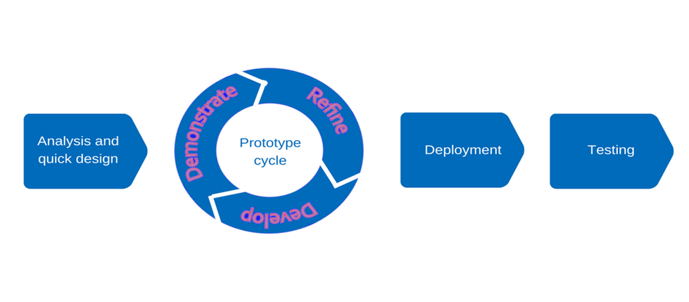

Figure 1. Rapid Application Development SDLC Model

Figure 1 displays the processes of software development that should be done in order to reach the satisfactory level of the system. The Rapid Application Development (software) development life cycle (O-O SDLC) has six important steps needed to be encompassed in order to produce a full-developed system.

**Analysis and Quick Design**

The proponents prepared a letter of permission to conduct a preliminary interview and observation on the principal of the institutions. The proponents asked for their way of making the grades of the Jr. and Sr. students per grading system. The proponents found out that their current system is a manual in form through the use of Microsoft Excel. After the interview, the proponents conducted a thorough analysis on how to make an easiest and fastest way just to compute the grades of every student. Then the proponents identified the platform to be used for the development of the system. In designing the proponents plan to provide an easy way to understand UI (user interface). There’s a separated design between students and teachers/faculty, the teachers could log in using their username and password that they could upload the grades of every student, so the students may view their grades through online.

**Demonstrate**

In demonstrating the proponents includes dataflow on how the system works by knowing the requirements in encoding data from the students that should be saved to the system and on how the system works best and has an efficiency to establish the data of the students. It as an output by the use of website.

**Refine**

In refining the proponents make an improve and perfect system on how to improve the manual grading process in the institution. On how to develop the manual process if the system is working or not working.

**Develop**

In Developing the proponents develop a reliable and workable system on the institution works effectively and efficiently that every teacher’s/faculty can benefits as well as the students.

**Deployment**

In deployment the proponents pick up some relevant information for addressing the issues. They are address in parallel with software construction, for example if the user must be trained in the use of the new system and their business process, changes and functional design must be finalized.

**Testing**

After the development and implementation phase, the system must have to undergo through testing to eliminate bug and error codes and it is a great requirement for the development of the system. And if the system is fully operational, this have to be maintain the quality and performance of the system. The proponents must have to include software upgrades, repairs, and fix of the software if it is break and if it is not working.

**Context Diagram**

The context diagram shows the general flow of processes of the developed system where an entity concerned is connected to a one main process. It also portrays the general input requirement and its process output.

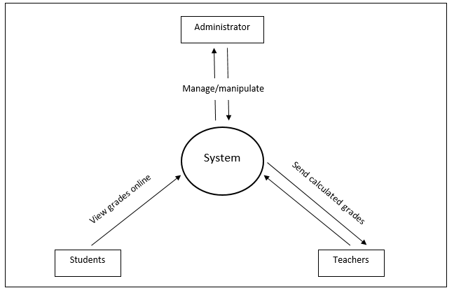

Figure 2. Context Diagram of Online Submission and Viewing of grades with android Application for Jr. and Sr. students of SMA.

Figure 2 shows the general processes of the development system. It also demonstrates the input needed to the send the data from the server and the expected process output from the system.

All the concepts of this study is applied in this diagram to help the management in having an accurate result in terms of providing an Online submission and viewing of grades of the juniors and senior’s students of Stella Maris Academy.

**Data Flow Diagram**

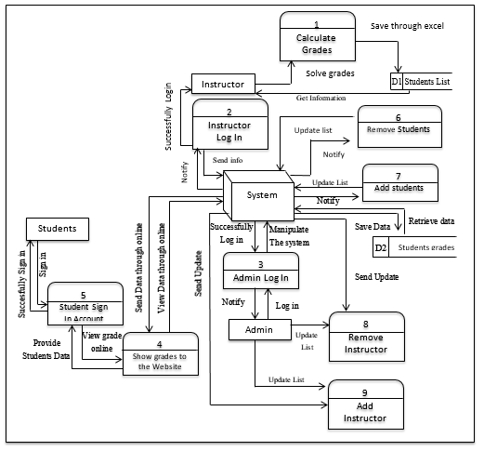The data flow diagram illustrates the flow of data, input requirements and processed output of the develop system.

Figure 3. Data Flow Diagram of Developed System

Figure 3 shows the entire data flow, the processes, input, requirements, processed outputs and the storage of developed system.

**Use Case Diagram**

The use case diagram shows the users interaction with the system and its relationships between different use cases and the user is involved.

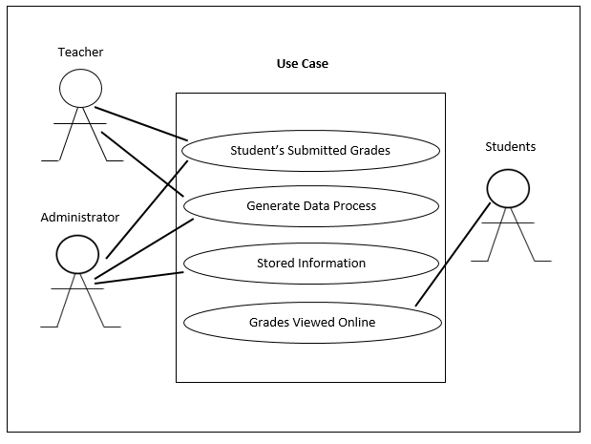

Online Submission and viewing of grades with Android Application for the Juniors and Seniors Students of SMA

Figure 4. Use Case Diagram of the Proponents Development System

Figure 4 shows the major tasks that actors must be done in order to implement the system. The operation of the online submission and viewing of grades with android application for juniors and senior’s students of Stella Maris Academy is that, first the teachers/faculty will compute the scores of each student per grading system, then the data of each student should be send to the system then the admin should upload the grades of the students through online that the students can view their grades freely.

The corresponding use case description for this above actors are:

**Actors:**

**Teachers/Instructors:** the one who are responsible in computing the grades of all the students using Microsoft excel by the process of gradingsystem.

**Administrator:** the one that is capable in storing and keeping all records, data, and information of the students. The persons who has a biggest role to operate and manipulate or manage the system.

**Students:** that the students will be able to use the application to view their grades using their mobile phones.

**Use Case Descriptions**

Table below describes the function, conditions and alternative flows to be met of all the entities used in the use case diagram.

Table 3. Student’s Submitted Grades

|  |  |
| --- | --- |
| **Use case name** | Student’s Submitted Grades |
| **Primary Actors** | Teachers/Instructor, Administrator |
| **Descriptions** | This use case describes how a teachers/instructors submitted a student’s grades. |
| **Pre-Conditions** | Teachers/Instructors – Must be responsible for the calculation of grades.  Administrator – Receive the data from the teachers. |
| **Post-Conditions** | Teachers/Instructors – Provide a proper encoding of grades of the students.  Administrator – Process the data. |
| **Main success Scenario** | Teachers/Instructor – Sent the grades on time to the system. |

Table 4. Generate Data Process

|  |  |
| --- | --- |
| **Use case name** | Generate Data Process |
| **Primary Actors** | Administrator |
| **Descriptions** | This use case describes how an administrator generate the data process. |
| **Pre-Conditions** | Administrator – Must be perform quickly and efficiency. |
| **Post-Conditions** | Administrator – Receive data or information of the students sent by the teachers/Instructor. |
| **Main success scenario** | 1. Administrator - Accurately checked and process the data. The Administrator is responsible to manage the data to produce an output. |

Table 5. Stored Information

|  |  |
| --- | --- |
| **Use case name** | Stored Information |
| **Primary Actors** | Administrator |
| **Descriptions** | This use case describes how an administrator store the information. |
| **Pre-Conditions** | Administrator – Must be accurate by uploading the grades. |
| **Post-Conditions** | Administrator – list and record all the information of the students. |
| **Main success scenario** | 1. Administrator – The data or information must be stored to the database of the institution. The Administrator upload the grades of each student through internet. |

Table 6. Viewed Grades Online

|  |  |
| --- | --- |
| **Use case name** | Viewed Grades Online |
| **Primary Actors** | Students |
| **Descriptions** | This use case describes how an students viewed their grades through online. |
| **Pre-Conditions** | Students - Wait for the process of grades. |
| **Post-Conditions** | Students – received the data and information by teachers. |
| **Main success scenario** | 1. Students should be login using their account to access the system. view their grades online or even printed output. |

**Activity Diagram**

Activity diagram shows the activities done in each of the entities being performed during the process of the system.

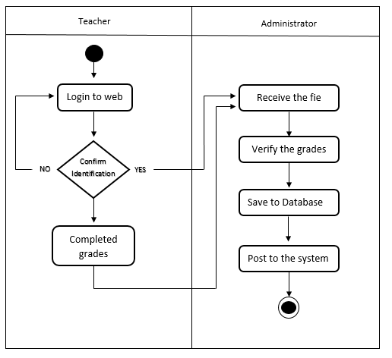

Figure 5. Submitting Grades of Students Activity Diagram of the Developed system

Figure 5 shows the steps on how the teachers calculate the final grades of the students that the admin receives the file from the teacher so that the data will be post to the system.

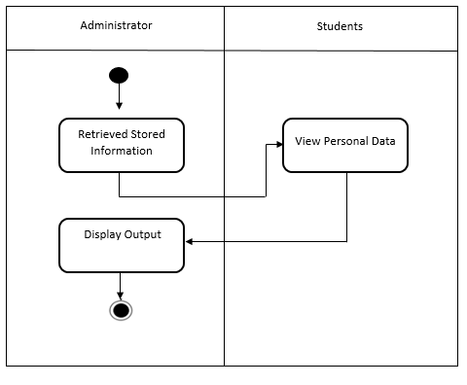

Figure 6. Generate the process of Activity Diagram of the Develop System

Figure 6 shows the steps on how the students can access their data using their unique ID number and password after they login they can already view their grades through online.

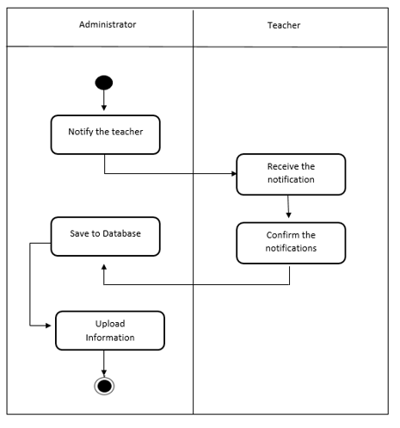

Figure 7. Stored Information of Activity Diagram of the Develop System

Figure 7 shows the steps on how the admin notify the teachers if the data will be upload to the website.

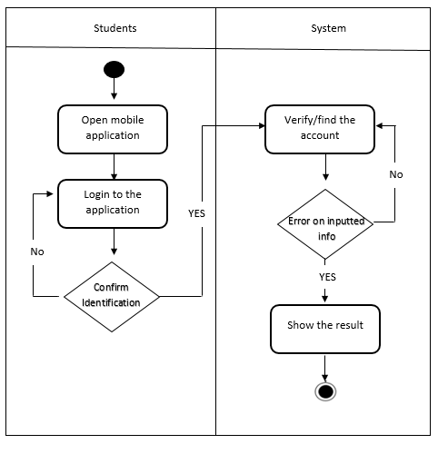

Figure 8. View Grades Online of Activity Diagram of the Develop System

Figure 8 shows the step on how the students can access their grades by signing in to the system.

**Decomposition Chart**

Decomposition chart shows the break down processes and its sub-processes of the whole system.

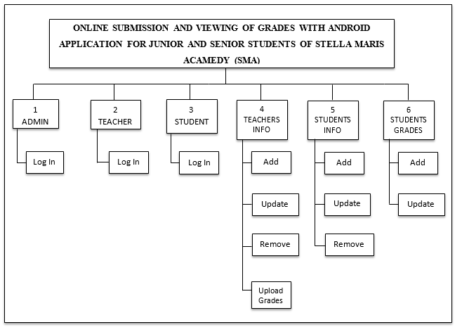

Figure 9. Decomposition chart of Online Submission and viewing of grades with Android Application for the Juniors and Seniors Students of SMA

Figure 9 shows the breakdown processes and its sub-processes of the developed system.

Every process has been labelled and marked to equate the functionality of the whole system.

**Entity Relationship Diagram**

Relational Database Management System (RDMS) is a Database Management System (DBMS) based on relation model of data. The conformity, the Entity Relationship Diagram shows the relationship and the connections of all tables in the database in a working system.

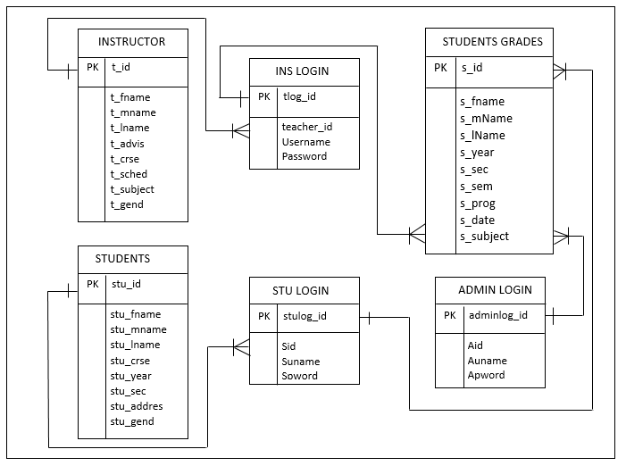

Figure 10. Entity Relationship Diagram of the

Proponents Developed System.

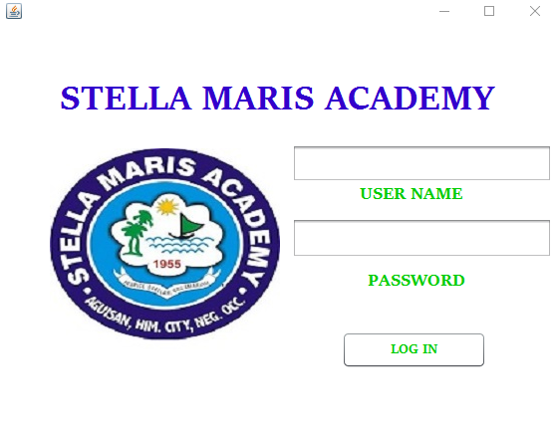 **Screen Layout and Design**

Figure 11. Log in page

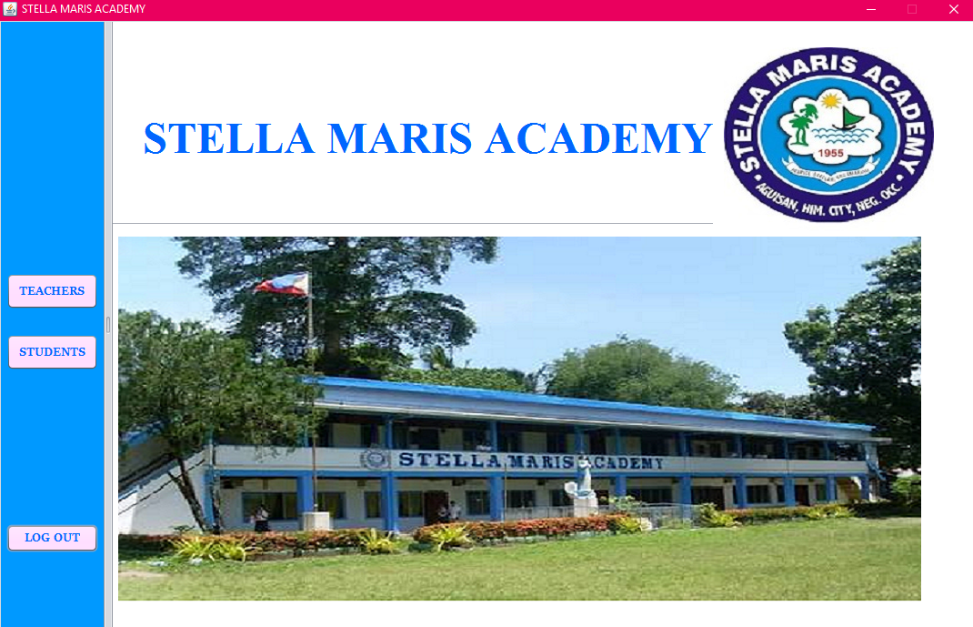Figure 11 shows the log in page of the system for the administrator and Instructor of the institutions.

Figure 12. Home page

Figure 12 Shows the Home layout of the administrator of the institutions.

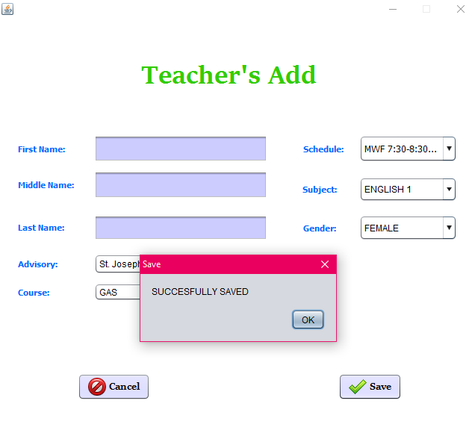

Figure 13. Teacher’s Successfully Add

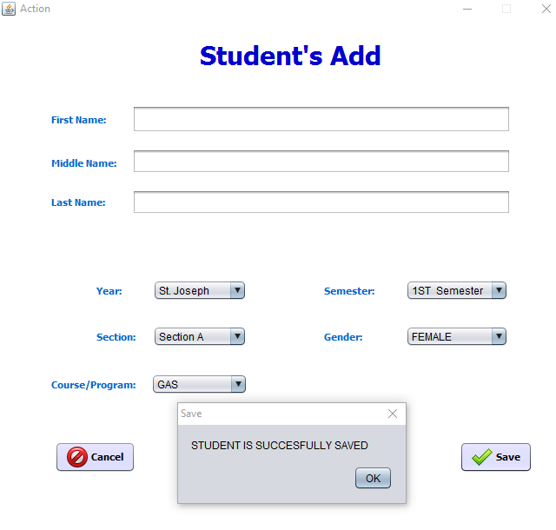Figure 13 shows the teachers successfully add to the database.

Figure 14. Student’s Successfully Add

Figure 14 shows the student’s Successfully save to the database of the system.

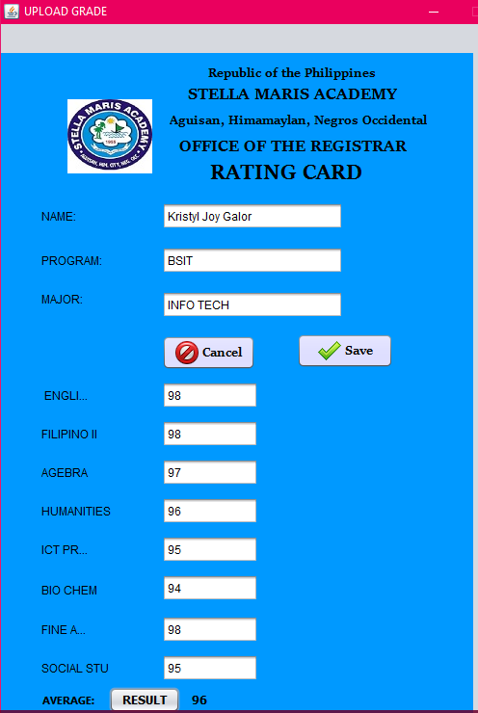

Figure 15. Students Grades

Figure 15 Shows the students grades save to the database of the system.

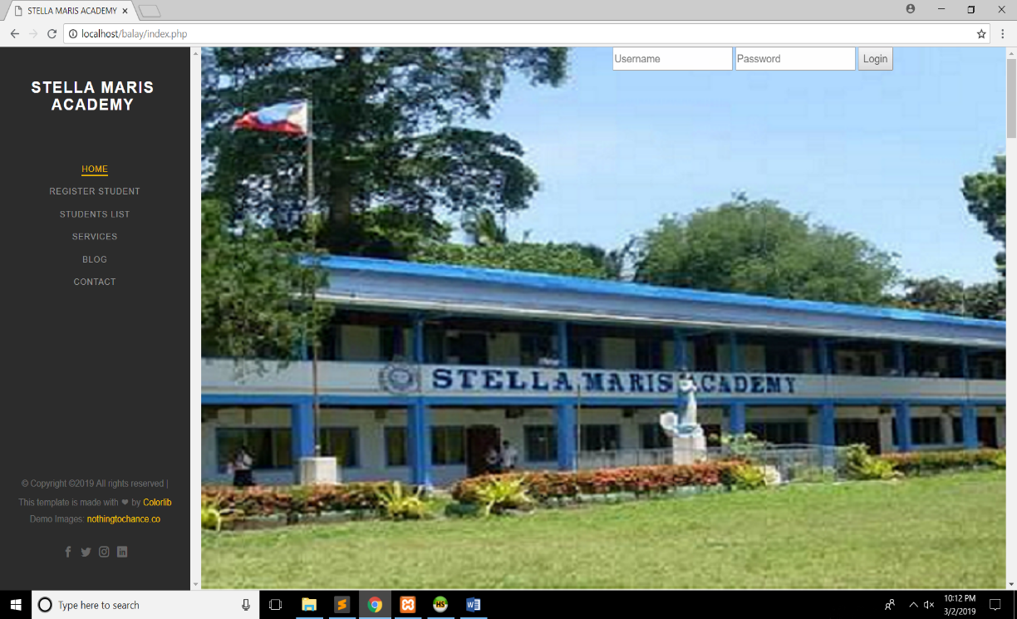

Figure 16. Website Home page

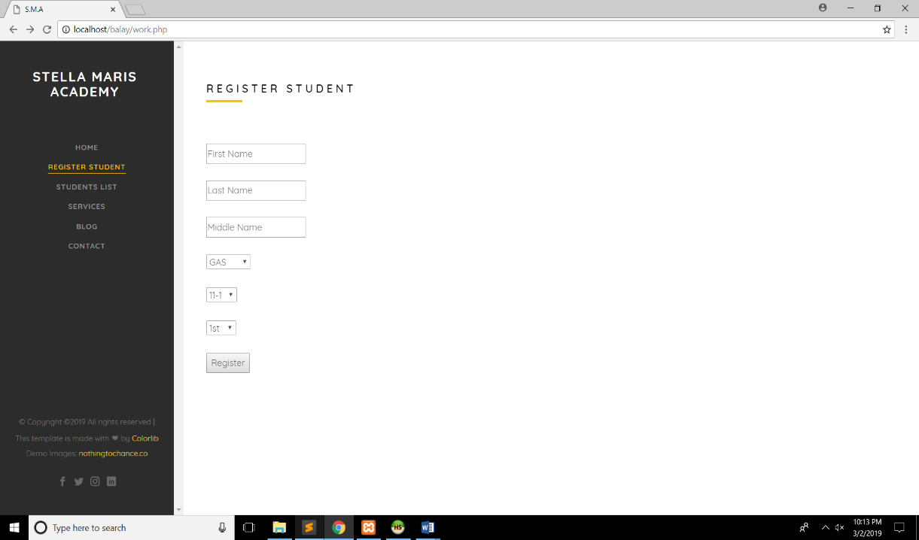Figure 16 Shows the website home page of Stella Maris Academy.

Figure 17. Register Student

Figure 17 Shows the screen displays of register students.

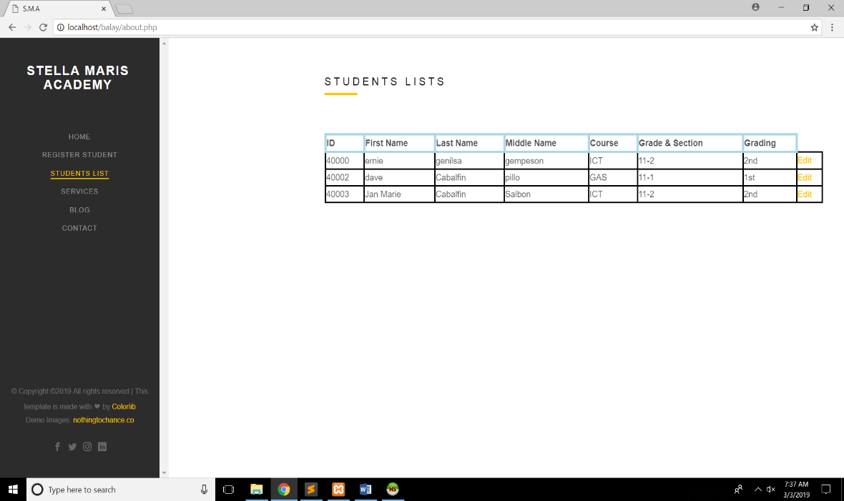

Figure 18. Students List

Figure 18 Shows the screen displays of student list when the students already save to the table.

**Architectural Framework**

The Architectural frameworks shows the system overall which the faculty/teachers will upload the final summations of the grades of the students using Microsoft Excel. And the acting Administrator will input through database provide by the system and with the use of internet the students can view or access their grades online.

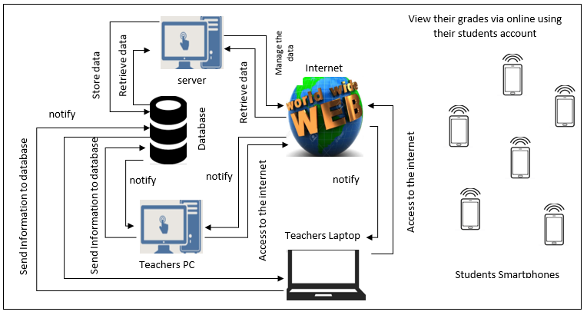

Figure 19. Architectural frameworks that the faculty/teachers will upload the final grades of the students.

**System Testing and Implementation**

In order to prove the system to the users if it is reliable and effective the user must test the system and give feedback to the proponents if the proposed system is effective in terms of its purpose. The proposed system has been tested by the 3rd year students of Carlos Hilado Memorial State College taking up Bachelor of Science in Information Technology. The proponents select our classmates and act as the costumers to test all the function of the system.

Online Submission and Viewing of grades with Android Application for Junior and Senior’s Students of Stella Maris Academy to provides the different features that are already done in their transaction processes as well as the recording data.

* Provide an easy way of dealing online viewing and submitting.
* Provides online document to the clients/costumer.
* Secure of recording information of the clients/costumer.
* Secure of online viewing and submitting records.

**Recommended Hardware Specification** (Server/Workstation)

Online Submission and Viewing of Grades with Android Application System for Stella Maris Academy be develops and run in a perfect function but first the client must implement the following hardware specification.

* Minimum 100GB Hard Drive
* Processor Type (32bit minimum) intel CORE i3 (or higher)

**Recommended Software Specification(Server/Workstation)**

* Windows Server 2008 Enterprise Edition (windows 7 or higher)
* NetBeans IDE version 8.2
* Heidi SQL version 8.3
* Xampp Control Panel v.3.2.2
* Sublime Text Editor

**Data Dictionary**

The tables below show the list of all the tables and the data stored in the database on the Online Submission and Viewing of grades with Android Application for Juniors and Seniors students of Stella Maris Academy. Its provide the attributes, data types and also the description for each fieldnames to recognize the data being stored in the database.

Table 7. AdminLogin

|  |  |  |  |
| --- | --- | --- | --- |
| Fieldname | Description | Type | Length |
| Apword | Password | VARCHAR | 20 |
| Auname | Username | VARCHAR | 50 |

Table 8. TeacherLogin

|  |  |  |  |
| --- | --- | --- | --- |
| Fieldname | Description | Type | Length |
| Tid | Teacher id | INT | 5 |
| Tpword | Password | VARCHAR | 20 |
| Tuname | Username | VARCHAR | 50 |

Table 9. StudentLogin

|  |  |  |  |
| --- | --- | --- | --- |
| Fieldname | Description | Type | Length |
| Sid | Student id | INT | 5 |
| Tpword | Password | VARCHAR | 20 |
| Tuname | Username | VARCHAR | 50 |

Table 10. StudentsInformaion

|  |  |  |  |
| --- | --- | --- | --- |
| Fieldname | Description | Type | Length |
| stu_id | student id | INT | 5 |
| stu_fname | Student’sfirstname | VARCHAR | 50 |
| stu_mname | Student’s middlename | VARCHAR | 50 |
| stu_lname | Student’s lastname | VARCHAR | 50 |
| stu_course | Student’s course | VARCHAR | 50 |
| stu_year | Student’s year | INT | 20 |
| stu_sec | Student’s section | VARCHAR | 2 |
| stu_address | Student’s address | VARCHAR | 50 |
| stu_gender | Student’s gender | VARCHAR | 20 |

Table 11. TeacherInfo

|  |  |  |  |
| --- | --- | --- | --- |
| Fieldname | Description | Type | Length |
| t_id | teacher id | INT | 5 |
| t_fname | Teacher’s firstname | VARCHAR | 25 |
| t_mname | Teacher’s middlename | VARCHAR | 25 |
| t_lname | Teacher’s lastname | VARCHAR | 25 |
| t_advis | Teacher’s advisory | VARCHAR | 50 |
| t_crse | Teacher’s course | VARCHAR | 25 |
| t_sched | Teacher’s schedule | INT | 10 |
| t_subj | Teacher’s subject | VARCHAR | 25 |
| t_gend | Teacher’s gender | VARCHAR | 25 |

Table 12. StudentsGrades

|  |  |  |  |
| --- | --- | --- | --- |
| Fieldname | Description | Type | Length |
| stu_id | student id | INT | 5 |
| stu_fname | Student’s firstname | VARCHAR | 25 |
| stu_mi | Student’s middleInitial | VARCHAR | 25 |
| stu_lname | Student’s lastname | VARCHAR | 25 |
| stu_prog | Students’s program | VARCHAR | 25 |
| stu_year | Student’s year | INT | 25 |
| stu_section | Student’s section | VARCHAR | 25 |
| stu_sem | Student’s semester | INT | 50 |
| Stu_subject | Student’s Subject | VARCHAR | 50 |
| stu_gend | Student’s Gender | VARCHAR | 25 |

**Gantt Chart**

Gantt Chart descries the overall activities in developing the system and application. This charts guide the proponents to manage time by recording the events occur during and after the process. This chart shows the measurement of length or how long it takes when doing the process of the system and application. By this Gantt chart, it is easy to figure out the delivery time of the proposed project.

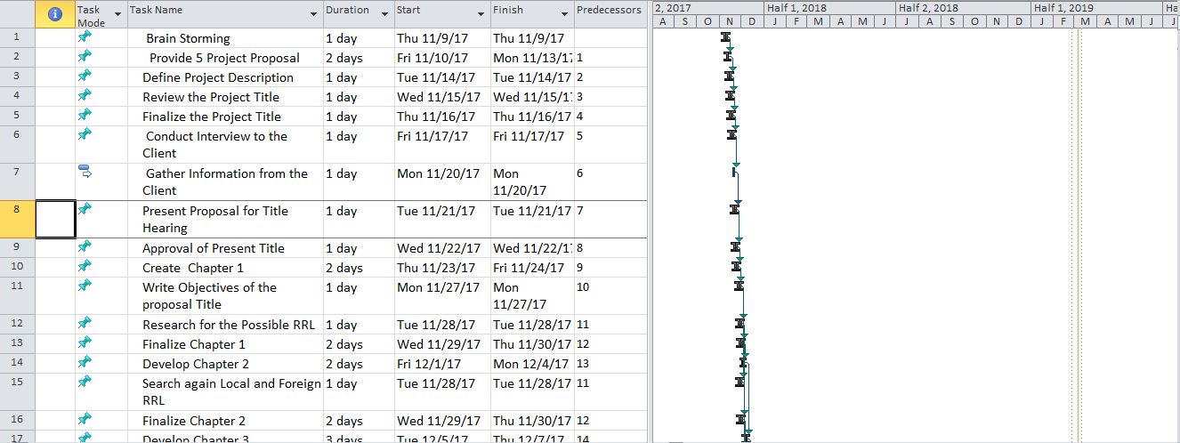

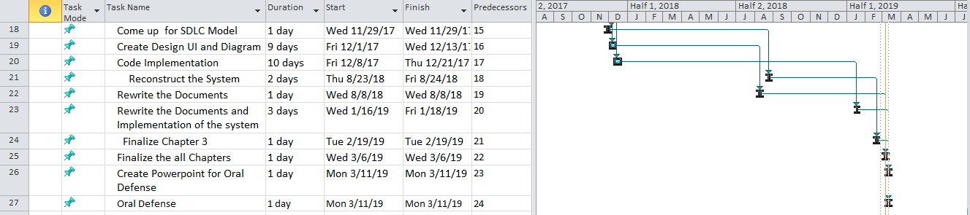

Figure 20. Gantt Chart

Figure 20 Shows the task and duration of activities that had been encountered. It provides the time management of the proponent to minimum overlapping of task in given time.

**Time Table**

The Time Table represents the sequence of the task and how long the task is to be completed. Preparing the task and its duration provide the proponent’s approximate schedule of the project and manage the details of the project.

|  |  |  |  |
| --- | --- | --- | --- |
| Task | Date Started | Date Finished | Assigned Members |
| Brain Storming | Thu 11/9/17 | Thu 11/9/17 | Cagas, Gramatico,Cabalfin |
| Provide 5 Project Proposal | Fri 11/10/17 | Fri 11/10/17 | Cagas, Gramatico,Cabalfin |
| Define Project Description | Tue 11/14/17 | Tue 11/14/17 | Cagas, Gramatico,Cabalfin |
| Review the Project Title | Wed 11/15/17 | Wed 11/15/17 | Gramatico,Cabalfin |
| Finalize the Project Title | Thu 11/16/17 | Thu 11/16/17 | Cagas, Gramatico,Cabalfin |
| Conduct Interview to the Client | Fri 11/17/17 | Fri 11/17/17 | Cagas, Gramatico,Cabalfin |
| Gather Information from the Client | Mon 11/20/17 | Mon 11/20/17 | Cagas, Gramatico,Cabalfin |
| Present Proposal for Title Hearing | Tue 11/21/17 | Tue 11/21/17 | Cagas, Gramatico,Cabalfin |
| Approval of Present Title | Wed 11/22/17 | Wed 11/22/17 | Cagas, Gramatico,Cabalfin |
| Create Chapter 1 | Thu 11/23/17 | Thu 11/23/17 | Cagas, Gramatico |
| Write Objectives of the proposal Title | Mon 11/27/17 | Mon 11/27/17 | Cagas, Gramatico |
| Research for the Possible RRL | Tue 11/28/17 | Wed 11/29/17 | Gramatico |
| Finalize Chapter 1 | Wed 11/29/17 | Wed 11/29/17 | Cagas, Gramatico,Cabalfin |
| Develop Chapter 2 | Fri 12/1/17 | Fri 12/1/17 | Cagas, Gramatico,Cabalfin |
| Search again Local and Foreign RRL | Tue 11/28/17 | Tue 11/28/17 | Cabalfin |
| Finalize Chapter 2 | Wed 11/29/17 | Wed 11/29/17 | Cagas, Gramatico,Cabalfin |
| Develop Chapter 3 | Tue 12/5/17 | Tue 12/5/17 | Cagas, Gramatico,Cabalfin |
| Come up for SDLC Model | Wed 11/29/17 | Wed 11/29/17 | Cagas,Cabalfin |
| **I. ANALYSIS AND DESIGN** |  |  |  |
| Create Design UI and Diagram | Fri 12/1/17 | Wed 12/13/17 | Cagas |
| Code Implementation | Fri 12/8/17 | Thu 12/21/17 | Cagas,Gramatico |
| Reconstruct the System | Thu 11/30/17 | Fri 12/1/17 | Cagas, Gramatico |
| Edit the color of the system | Thu 12/01/17 | Thu 8/23/18 | Cagas, Gramatico |
| **II. DEVELOPMENT** |  |  |  |
| Rewrite the Documents | Wed 8/8/18 | Wed 8/8/18 | Gramatico,Cabalfin |
| Rewrite the Documents and Implementation of the  System | Wed 1/16/19 | Fri 1/18/19 | Cagas,Gramatico,  Cabalfin |
| Finalize Chapter 3 | Tue 2/19/19 | Tue 2/19/19 | Cagas,Gramatico,  Cabalfin |
| Finalize the all Chapters | Wed 3/6/19 | Wed 3/6/19 | Cagas,Gramatico,  Cabalfin |
| Create Powerpoint for Oral Defense | Mon 3/11/19 | Mon 3/11/19 | Cagas,Gramatico,  Cabalfin |
| Oral Defense | Mon 3/11/19 | Mon 3/11/19 | Cagas,Gramatico,  Cabalfin |

Table 13. Time Table